
Sukkur IBA University
Department of Computer Science
ESE-201: Digital Logic Design Lab

Lab # 12: JK-Flip Flop
Instructor: Muhammad Ismail Qureshi
Submission Profile
Name: Ghulam Mustafa Submission date 25/12/2025
CMS ID: 023-24-0513 Marks obtained:
Comments: Receiving authority name and signature:

________________________________________________________________________________
Instructor Signature

Note: Submit this lab hand-out on LMS/e-learning before the next lab with attached solved activities and exercises.
Lab Learning Objectives:

Upon successful completion of this experiment, the student will be able:
- To implement and verify JK flip flop operations using 74LS76 IC & NI ELVIS II Kit

Lab Hardware and Software Required:
- 74LS76 IC
- NI ELVIS Kit
- Breadboard
- Connecting Wires

Background Theory:

JK-FLIP FLOP:
The JK-flip flop is very versatile and is perhaps the most widely used type of flip flops. The J and K designation for the inputs have no known significance except that they are adjacent letters in the alphabet. The functioning of the JK flip flop is identical to that of RS flip flops in the SET, RESET and no change condition of operation. The difference is that the JK flip flop has no invalid state as does the RS flip flop. Therefore the JK flip flop is a very versatile device that finds application in digital system. Fig 12.1 (a & b) shows a logic symbol and logic diagram for the JK flip flop.
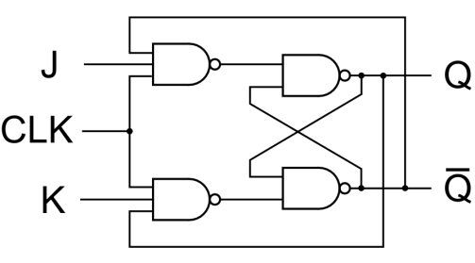
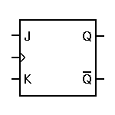

Fig 12.1: (a) Logic symbol of JK-flipflop (b) Logic diagram of JK-flip flop
The data at the J and K inputs of the JK flip flop controls its output. Notice that it differs from the RS flip flop in the output of the flip flop is coupled back to input. J and K inputs control the state of the flip flop in the same way as the S and R inputs do for the clocked RS flip flop except for one major difference; the J=K=1 condition does not result in ambiguous output. For this 1, 1 condition, the flip flop always go to its opposite state upon the arrival of the clock signal. This is called the toggle mode of states (toggle) for each of the clock pulse.
74LS76 JK Flip Flop IC:
The 74LS76 is a popular JK flip flop IC; having dual flip flops (two flip flops in each IC package). Its pin configuration is given in Fig 12.2. It has only asynchronous inputs (RD and SD) as well as synchronous inputs (CP, J, K) and is negative-edge triggered flip flop. The asynchronous inputs RD and SD are active low, that is low on SD (set) will set the flip flop (Q=1) and low on RD will reset the flip flop (Q=0). The asynchronous input will cause the flip flop to respond immediately without regard to the clock trigger input CP. For synchronous operation using J, K, and CP, the asynchronous inputs must be disabled by putting a high level on both.
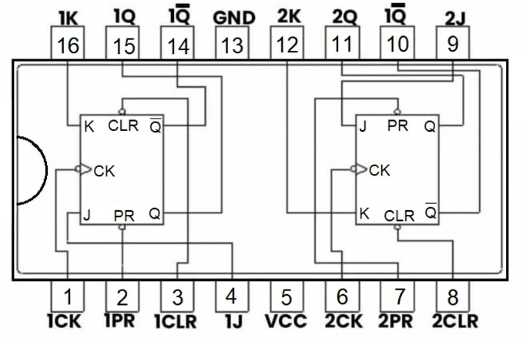
Fig 12.2: Pin configuration of 74LS76 JK flip-flop IC
Lab Examples:
Implementation of JK flip flop using 74LS76 IC:
- Carry out the circuits of Fig 12.2 by using IC 74LS76
- Make the circuit on breadboard present on the NI ELVIS II kit
- Apply power supply to it
- Connect the inputs J & K of circuit to the switches
- Connect the terminal of clock to the input CK of the flip flop
- Connect the outputs Q and $\overline{Q}$ of both circuits to the LEDs
- Analyze the circuit’s behaviour by carrying out different combinations with the switches and fill the observation tables
Table 12.1: Observation table of JK flip flop
Inputs |  |  | Outputs
CK | K | J | Q | $$\overline{Q}$$
↑ | X | X | 1/0 | 0/1
↓ | 0 | 0 | 1 | 0
↓ | 0 | 1 | 0 | 1
↓ | 1 | 0 | 1 | 0
↓ | 1 | 1 | 1/0(blink) | 1/0(blink)

Lab Activities:
How can we convert J K flip into D flip flop?

Think of the JK flip-flop as a clever switch that asks two questions every clock tick: Should I set? Should I reset?
A D flip-flop is simpler. It listens to one voice only: Whatever D says, I become.
So the trick is to whisper to J and K in just the right way so they behave like a single D. 🧠✨

Step 1: Recall JK flip-flop behavior
The next state equation of a JK flip-flop is:
Q_{n+1} = J$\overline{Qn }$+ KQ_{n}

Step 2: What does a D flip-flop do?
Very straightforward:
Q_{n+1} =D
We want the JK equation to collapse into D.

Step 3: Choose J and K cleverly
Set:
- J = D
- K = \overline{D}
Now substitute into the JK equation:
Q_{n+1} = D$\overline{Qn }$+ DQ_{n}

Factor D:
Q_{n+1} = D($\overline{Qn }$+ Q_{n})

Since $\overline{Qn }$ + Q_{n} = 1):
Q_{n+1}= D
Final Answer
To convert a JK flip-flop into a D flip-flop:
- Connect J = D
- Connect K = D̅ (use a NOT gate)
Block idea (textual):
D ─────► J
│
└─► NOT ─► K

Lab Exercises:
Implement JK flip flop in Multisim, attach circuit diagram and observed waveforms.

